


Case study protocol, interview guidelines and group reports for students

I N N O N A T O U R
Carmen NĂSTASE
Project Coordinator
University „Stefan cel Mare” of Suceava

Suceava, Romania 2011
Innovation in Nature Based Tourism Services

Contents

1. Introduction 3
2. What is innovation 4
3. Course content 8
4. Methodology of the pre-case study 9
5. Guidelines for group reports 10
6. Methodology of the post-case study 11

1. Introduction

This document intends to guide the case study work of the students in the Erasmus Intensive Programme INNO NATOUR.

The case study aims at the documentation of an innovation project carried out by one innovative tourism enterprise from your country.

The object of analysis is the innovation process management and innovation tools of this enterprise. On the basis of the collected material the innovation case will be analysed during the two IP weeks in Suceava, Romania. For that, the outline of the report will be needed in Suceava course. The final report will be finalised after the Suceava course.

Also, this document intends to guide you for the group work reports which you will have to complete during 11 days of the IP.

2. What is innovation

The innovation is all the novelties introduced in the market, only a little part of them are successful and they are the result of a long process. The innovation can be tangible like a new product or process, and not tangible like a new service.
The innovation is not only the introduction of new product or services, but also the improvement of them, it’s possible to integrate traditional system or product with new ones, because the consumer demands are different and the solutions are more.

Why do we need to innovate? The answer is simple:
- for economic growth
- for competitiveness
- for creation of new employment places
- for rural and regional development generally, especially for the local community
- for environmental improvement and sustainable development.

The process of implementation must be based on a very well established plan that can guarantee the exact results that are expected. This plan includes a standard set of elements, such as:
- business description: products and services offered
- market strategies
- competitive analysis and positioning
- operations and management plan
- financial components

It is well-known that economic growth is a result of new combinations of products, processes, markets, sources of supply, and organizations – that is: innovations. (Schumpeter (1911))

Innovations may be categorized into the following types (Figure no 1).

Figure no 1 – The innovation categories

The process of innovation in an organization can be categorized according to the stages in the innovation decision process (Rogers 1995):
1. Prior conditions:
- Previous practice
- Felt needs / problems
- Innovativeness
- Norms of the social system
2. Knowledge – the characteristics of the decision making unit are:
- Socio-economic characteristics (education, social status, economic orientation,...)
- Personality variables (attitude towards education, fatalism, achievement motivation, )
- Communication behavior (interconnectedness, active information seeking, change agent contact)
3. Persuasion – related to the perceived characteristics of the innovation
- Relative advantage
- Compatibility
- Complexity
- Trial ability
- Observability
4. Decision (adoption or rejection)
5. Implementation
6. Confirmation

Knowledge

Prior
Conditions

Confirmation

Persuasion

Decision
Implemen-tation

Figure no. 2: Stages of innovations – the firm level view (Rogers 1995)

3. Course content
10 ECTS credits
- Pre studies 4 ECTS credits (at home institution)
- Contact course 3 ECTS credits (in Suceava / Romania)
- Post tasks 3 credits (at home institution)

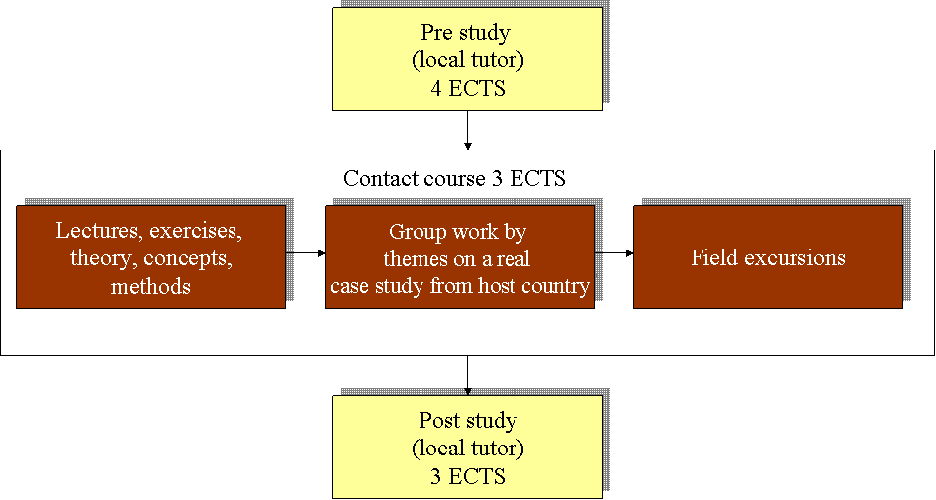

4. Methodology of the pre-case study

The goal of the case study work is to understand the innovation processes and innovation management. In order to accomplish that, please provide information about the enterprise you will visit for the Inno Natour case study, and offer innovative solutions to the stakeholders.
The list below intends to help you to collect this information. The list is equally applicable to all enterprises. You are free to collect more information as you consider necessary.

The pre study will be presented at the IP Course from Suceava and you should prepare a max 10 minutes Power Point presentation and also a printed poster.
The following categories should be included as part of your pre case study.

1. Name of the enterprise
2. Location
3. Business address
4. Contact information
5. Year established
6. Company background | Give a brief history of the company, number of employees, management style, etc.
7. Legal form of enterprise
8. Persons engaged in managing the enterprise (chief executive manager) | - proprietor(s)  - hired managers(s)  - family members
9. Annual turnover
10. Market and competition situation | What competing products/services there exists? How this is different from those? Is it radical or incremental? Who are the main actors in those markets? Who are the leading actors (setting the rules)? What is your innovation strategy (sustaining, disruptive or new markets)?
11. Partners
12. Innovation case | Description and analysis of the innovation system - Describe the relevant original manufacturing process or original services which the enterprise offers.
13. The present economical crisis | How did influence the present economical world crisis the enterprise
14. Lessons learnt: problems and challenges, fostering and impeding factors | It is of special interest, what challenges were faced, what problems had to be solved, and what lessons were learnt in course of the innovation process. The analysis should finally identify the fostering and impeding factors in the innovation process

5. Guidelines for group reports

During this IP, each working group will have to present 2 reports:
- An intermediary report
- A final report

1. Intermediary report contents:

- description of the enterprise, SWOT analysis, problem definition, aim and first drafts of innovation, future activities of the group
- to be supported by Power Point presentation in seminar

2. The final report contents:
- to be produced as printable word document
- recommended length 7-10 pages
- supported by Power Point presentation in final seminar
- identification information on cover page:
  - name and logo of the IP course
  - place, date
  - theme group
  - members of group
  - Erasmus logo

Contents:

- description of the case study
- description of case process
    - organization of the group and group work process
    - phases of the case process and their main results
    - methods and tools used
- SWOT analysis
- problem definition
- how did influence the present economical world crisis the enterprise
- innovation plan
    - utilization of innovation system
    - conditions for realization of innovation
    - stages for realization of innovation
    - estimation of resources needed and funding possibilities
- applicability to group members’ home country
- sources of information

6. Methodology of the post-case study

After the participation to the Erasmus IP course INNO NATOUR in Suceava, Romania, each student will write a case study report containing issues that are given in the following. The case study will be send on e-mail to the tutor and to the following addresses: ncarmen@usv.ro, hodoroaba.alina@yahoo.com until 1 June 2011.

About 10 pages (final report) report including:

Cover page

Abstract

Contents

Introduction

Case study descriptions (depending on the case)

  - innovation, customer and customer needs, market and competition situation, description of organization, innovation process, innovation tools and methods, innovation environment, partners, innovation services, how to benefit the innovation (capture) business concepts, protection, marketing, production and delivery, management, future development, and other needed descriptions

How did influence the present economical world crisis the enterprise

SWOT analysis of the enterprise’s innovation ability

Conclusions

  - lessons learnt, recommendations

Sources of information

