


Case study protocol, interview guidelines and group reports for students

I N N O N A T O U R
Carmen NĂSTASE
Project Coordinator
University „Stefan cel Mare” of Suceava

Suceava, Romania 2010
Innovation in Nature Based Tourism Services

Contents

1. Introduction 3
2. What is innovation 4
3. The innovation to the European level 6
4. Course content 8
5. Methodology of the pre-case study 9
6. Guidelines for group reports 10
7. Methodology of the post-case study 11

1. Introduction

This document intends to guide the case study work of the students in the Erasmus Intensive Programme INNO NATOUR.

The case study aims at the documentation of an innovation project carried out by one innovative tourism enterprise from your country.

The object of analysis is the innovation process management and innovation tools of this enterprise. On the basis of the collected material the innovation case will be analysed during the two IP weeks in Suceava, Romania. For that, the outline of the report will be needed in Suceava course. The final report will be finalised after the Suceava course.

Also, this document intends to guide you for the group work reports which you will have to complete during 11 days of the IP.

2. What is innovation

The innovation is all the novelties introduced in the market, only a little part of them are successful and they are the result of a long process. The innovation can be tangible like a new product or process, and not tangible like a new service.
The innovation is not only the introduction of new product or services, but also the improvement of them, it’s possible to integrate traditional system or product with new ones, because the consumer demands are different and the solutions are more.

Why do we need to innovate? The answer is simple:
- for economic growth
- for competitiveness
- for creation of new employment places
- for rural and regional development generally, especially for the local community
- for environmental improvement and sustainable development.

The process of implementation must be based on a very well established plan that can guarantee the exact results that are expected. This plan includes a standard set of elements, such as:
- business description: products and services offered
- market strategies
- competitive analysis and positioning
- operations and management plan
- financial components

It is well-known that economic growth is a result of new combinations of products, processes, markets, sources of supply, and organizations – that is: innovations. (Schumpeter (1911))

Innovations may be categorized into the following types (Figure no 1).

Figure no 1 – The innovation categories

The process of innovation in an organization can be categorized according to the stages in the innovation decision process (Rogers 1995):
1. Prior conditions:
- Previous practice
- Felt needs / problems
- Innovativeness
- Norms of the social system
2. Knowledge – the characteristics of the decision making unit are:
- Socio-economic characteristics (education, social status, economic orientation,...)
- Personality variables (attitude towards education, fatalism, achievement motivation, )
- Communication behavior (interconnectedness, active information seeking, change agent contact)
3. Persuasion – related to the perceived characteristics of the innovation
- Relative advantage
- Compatibility
- Complexity
- Trial ability
- Observability
4. Decision (adoption or rejection)
5. Implementation
6. Confirmation

Knowledge

Prior
Conditions

Confirmation

Persuasion

Decision
Implemen-tation

Figure no. 2: Stages of innovations – the firm level view (Rogers 1995)

3. THE INNOVATION TO THE EUROPEAN LEVEL

Starting from 2003, the difference from the innovation levels of the European Union and, respective of the United States, is going lower from one year to another, according to the report „European Innovation Scoreboard 2009”.
The EIS 2009 includes innovation indicators and trend analyses for the EU27 Member States as well as for Croatia, Serbia, Turkey, Iceland, Norway and Switzerland. Based on their innovation performance across 29 indicators, EU27 Member States fall into the following four country groups:
- Denmark, Finland, Germany, Sweden and the UK are the Innovation leaders, with innovation performance well above that the EU27 average and all other countries. Of these countries, Germany and Finland are improving their performance fastest while Denmark and the UK are stagnating.
- Austria, Belgium, Cyprus, Estonia, France, Ireland, Luxembourg, the Netherlands and Slovenia are the Innovation followers, with innovation performance below those of the Innovation leaders but close to or above that of the EU27 average. Cyprus, Estonia and Slovenia have shown a strong improvement compared to 2008, providing an explanation why these countries have moved from the Moderate innovators in the EIS 2008 to the Innovation followers,
- Czech Republic, Greece, Hungary, Italy, Lithuania, Malta, Poland, Portugal, Slovakia and Spain are the Moderate innovators, with innovation performance below the EU27 average. The EIS 2009 Moderate innovators are a mix of 5 Member States which were Moderate innovators in the EIS 2008 and 5 Member States which were Catching-up countries in the EIS 2008.
- Bulgaria, Latvia and Romania are the Catching-up countries with innovation performance well below the EU27 average. All three countries are rapidly closing their gap to the average performance level of the EU27, and Bulgaria and Romania have been improving their performance the fastest of all Member States.
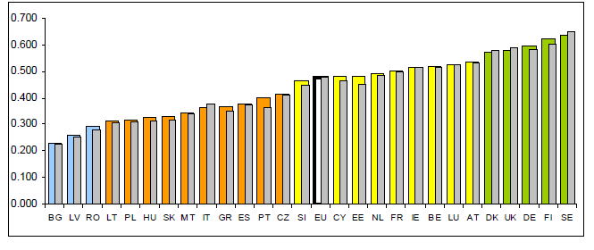
Figure no. 3 - Summary innovation performance EU27 Member States (2009 SII)*
Source: European Innovation Scoreboard 2009, page 3

*Note: The Summary Innovation Index (SII) is a composite of 29 indicators going from a lowest possible performance of 0 to a maximum possible performance of 1. The 2009 SII reflects performance in 2007/2008 due to a lag in data availability.
The grey coloured columns show 2008 performance as calculated backward from 2009 using the next-to-last data for each of the indicators. This 2008 performance is not identical to that shown in the EIS 2008 as not for all indicators data could be updated with one year. The difference between the columns for 2008 and 2009 show the most recent changes in innovation performance.

This year’s assessment shows that there continues to be convergence amongst the groups, with Moderate innovators and the Catching-up countries growing at a faster rate than the Innovation leaders and Innovation followers.
Germany, Cyprus, Malta and Romania are the EU27 countries displaying the largest improvement within their peer groups.
Within each of the country groups there is variation in growth performance, with Finland and Germany showing the best growth performance of the Innovation leaders. Cyprus, Estonia and also Slovenia are the fastest growing Innovation followers. Czech Republic, Greece, Malta and Portugal are the fast growing Moderate innovators and Bulgaria and Romania are not only the fastest growers among the Catching-up countries but also overall.

The economic crisis may lead to a reversal of the convergence between EU27 countries in innovation performance. The 2008 European Innovation Scoreboard showed a clear process of convergence between EU27 Member States. The 2009 Scoreboard does not capture any possible impacts of the crisis, as most data come from 2007 and 2008. However, data from the 2009 Innobarometer survey suggests that the rapid advances in innovation performance made in many lower performing countries may not be maintained, at least in the short term, due to the severity of the economic crisis.

4. Course content
10 ECTS credits
- Pre studies 4 ECTS credits (at home institution)
- Contact course 3 ECTS credits (in Suceava / Romania, 26 April - 7 May 2010)
- Post tasks 3 credits (at home institution)

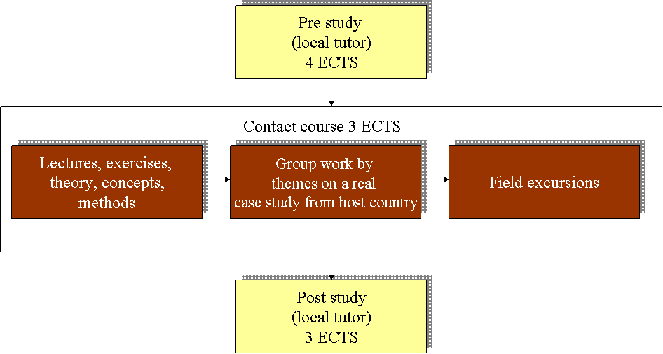

5. Methodology of the pre-case study

The goal of the case study work is to understand the innovation processes and innovation management. In order to accomplish that, please provide information about the enterprise you will visit for the Inno Natour case study, and offer innovative solutions to the stakeholders.
The list below intends to help you to collect this information. The list is equally applicable to all enterprises. You are free to collect more information as you consider necessary.

The pre study will be presented at the IP Course from Suceava and you should prepare a max 10 minutes Power Point presentation and also a printed poster.
The following categories should be included as part of your pre case study.

1. Name of the enterprise
2. Location
3. Business address
4. Contact information
5. Year established
6. Company background | Give a brief history of the company, number of employees, management style, etc.
7. Legal form of enterprise
8. Persons engaged in managing the enterprise (chief executive manager) | - proprietor(s)  - hired managers(s)  - family members
9. Annual turnover
10. Market and competition situation | What competing products/services there exists? How this is different from those? Is it radical or incremental? Who are the main actors in those markets? Who are the leading actors (setting the rules)? What is your innovation strategy (sustaining, disruptive or new markets)?
11. Partners
12. Innovation case | Description and analysis of the innovation system - Describe the relevant original manufacturing process or original services which the enterprise offers.
13. The present economical crisis | How did influence the present economical world crisis the enterprise
14. Lessons learnt: problems and challenges, fostering and impeding factors | It is of special interest, what challenges were faced, what problems had to be solved, and what lessons were learnt in course of the innovation process. The analysis should finally identify the fostering and impeding factors in the innovation process

6. Guidelines for group reports

During this IP, each working group will have to present 2 reports:
- An intermediary report
- A final report

1. Intermediary report contents:

- description of the enterprise, SWOT analysis, problem definition, aim and first drafts of innovation, future activities of the group
- to be supported by Power Point presentation in seminar

2. The final report contents:
- to be produced as printable word document
- recommended length 7-10 pages
- supported by Power Point presentation in final seminar
- identification information on cover page:
  - name and logo of the IP course
  - place, date
  - theme group
  - members of group
  - Erasmus logo

Contents:

- description of the case study
- description of case process
    - organization of the group and group work process
    - phases of the case process and their main results
    - methods and tools used
- SWOT analysis
- problem definition
- how did influence the present economical world crisis the enterprise
- innovation plan
    - utilization of innovation system
    - conditions for realization of innovation
    - stages for realization of innovation
    - estimation of resources needed and funding possibilities
- applicability to group members’ home country
- sources of information

7. Methodology of the post-case study

After the participation to the Erasmus IP course INNO NATOUR in Suceava, Romania, each student will write a case study report containing issues that are given in the following. The case study will be send on e-mail to the tutor and to the following addresses: ncarmen@usv.ro, hodoroaba.alina@yahoo.com until 1 June 2010.

About 10 pages (final report) report including:

Cover page

Abstract

Contents

Introduction

Case study descriptions (depending on the case)

  - innovation, customer and customer needs, market and competition situation, description of organization, innovation process, innovation tools and methods, innovation environment, partners, innovation services, how to benefit the innovation (capture) business concepts, protection, marketing, production and delivery, management, future development, and other needed descriptions

How did influence the present economical world crisis the enterprise

SWOT analysis of the enterprise’s innovation ability

Conclusions

  - lessons learnt, recommendations

Sources of information

