

Erasmus Intensive Programme (IP)
2009-10

Final report form for students

How satisfied were you with the duration of the IP:
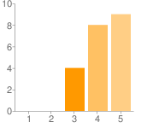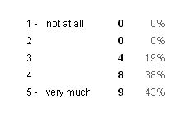

How satisfied were you with the dates of the IP?
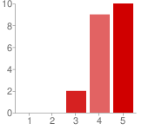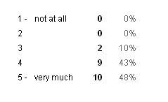

Which were the factors which motivated you to participate?
scale 1-5: 1=not at all, 5=very much

Academic
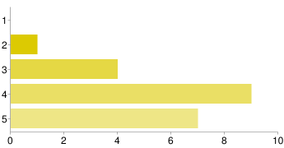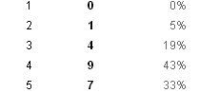

Cultural

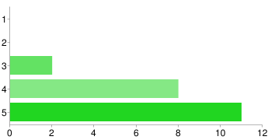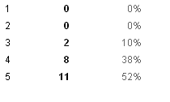

Practice of foreign language
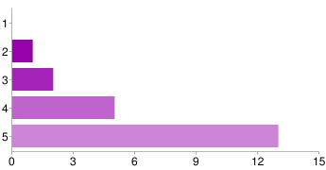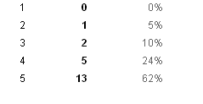

Friends living abroad
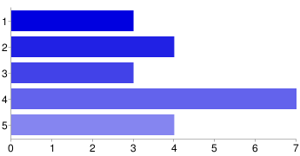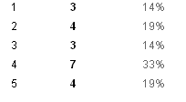

Career plans
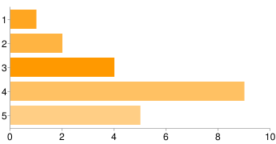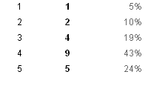

European experience
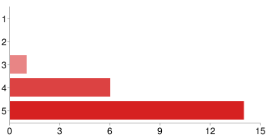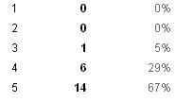

Other:
- see different places
- to have a little distraction from my home studies

Where did you hear about the IP?

- Home institution
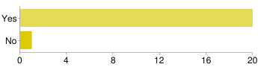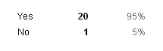

- Host institution
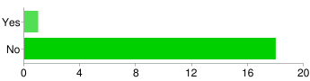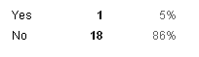

- Other students
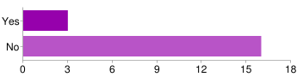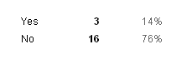

- Former participants
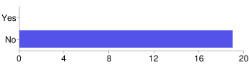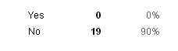

- Internet
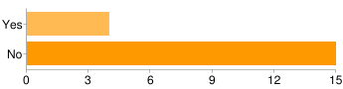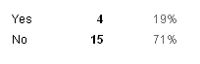

Did you receive adequate support from your home institution and from the host institution before and during the IP?
scale 1-5: 1=poor/negative, 5=excellent

- Home institution
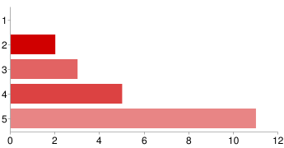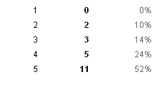

- Host institution
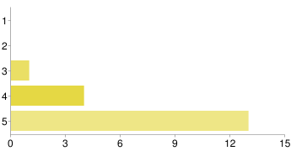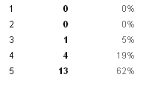

Were you satisfied with your accommodation?
scale 1-5: 1=not at all, 5=very much

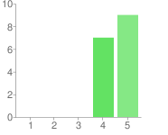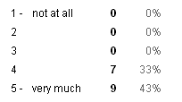

Will you gain recognition for your IP by your home institution?

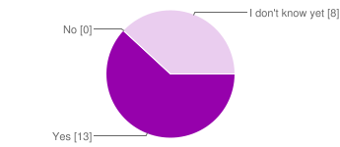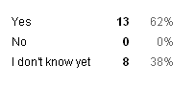

If yes, How will it be recognised?

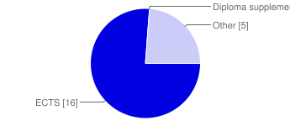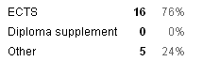

Judgement of academic/learning outcomes of the IP:
scale 1-5: 1=poor/negative, 5=excellent

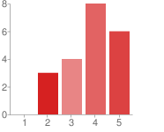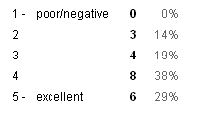

Judgement of personal outcomes of the IP:
scale 1-5: 1=poor/negative, 5=excellent

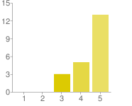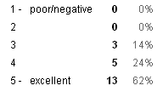

Did you encounter any serious problems during the IP?
scale 1-5: 1=not at all, 5=very much
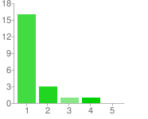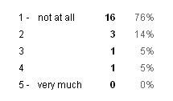

If yes, please specify:
- problems with my physical health

How satisfied were you with the academic activities and the pedagogical aspects of the IP in terms of the following aspects?
scale 1-5: 1=not at all, 5=very much

- The number of hours taught
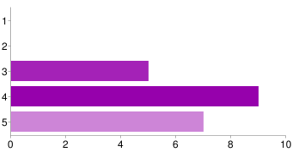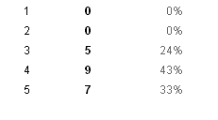

- The equipment used
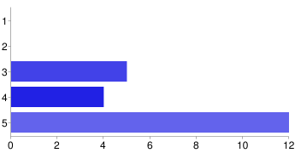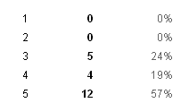
- The capabilities and expertise of the professors
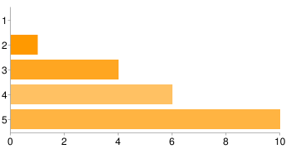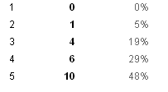

- The overall quality of teaching
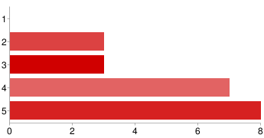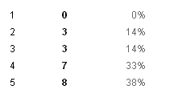

- The expected learning outcomes
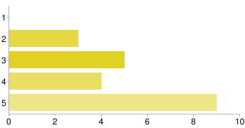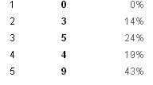

- The activities besides the general course
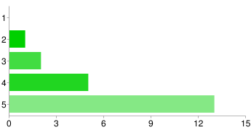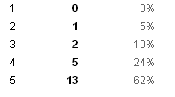

Do you think participation in the IP will help you in your further studies/career?
scale 1-5: 1=not at all, 5=very much

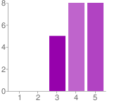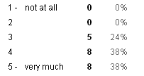

Do you think participation in the IP will help you in finding a job?
scale 1-5: 1=not at all, 5=very much

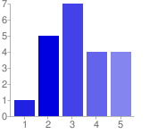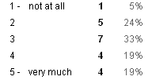

Overall evaluation of the IP:
scale 1-5: 1=poor/negative, 5=excellent

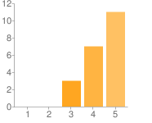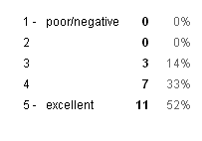

Recommendations and ideas for the IP organisers:

- My only critic for the IP course is the lections which were presented virtually (on internet) because the students are less actually involved in the lection, the less their attention could be captured/kept. So my proposition is for the lecturers - to be more accessible to the audience, to make the students participate in the lection, to involve them in it.
- Everything else was just perfect, so keep on doing like that.
- More shorter breaks
- Programme could be organised better - not so much waiting. Maybe more excursions
- More dialogue between participants
- More interaction between the working groups - like final reflection -> problems the other groups had and how they react on them would have been interesting to know
- Good Work!
- More IP courses
- I think that everything was just ok

