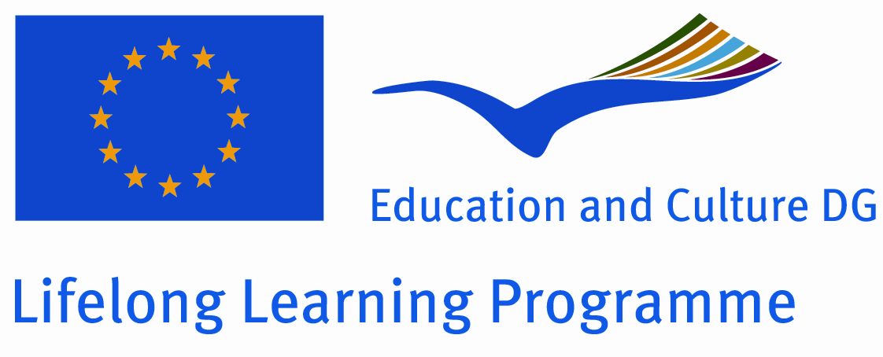
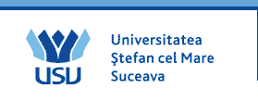
Stefan cel Mare University of Suceava, in cooperation with National Agency of the Lifelong Learning Programme

INNO NATOUR: Innovation in Nature Based Tourism Services
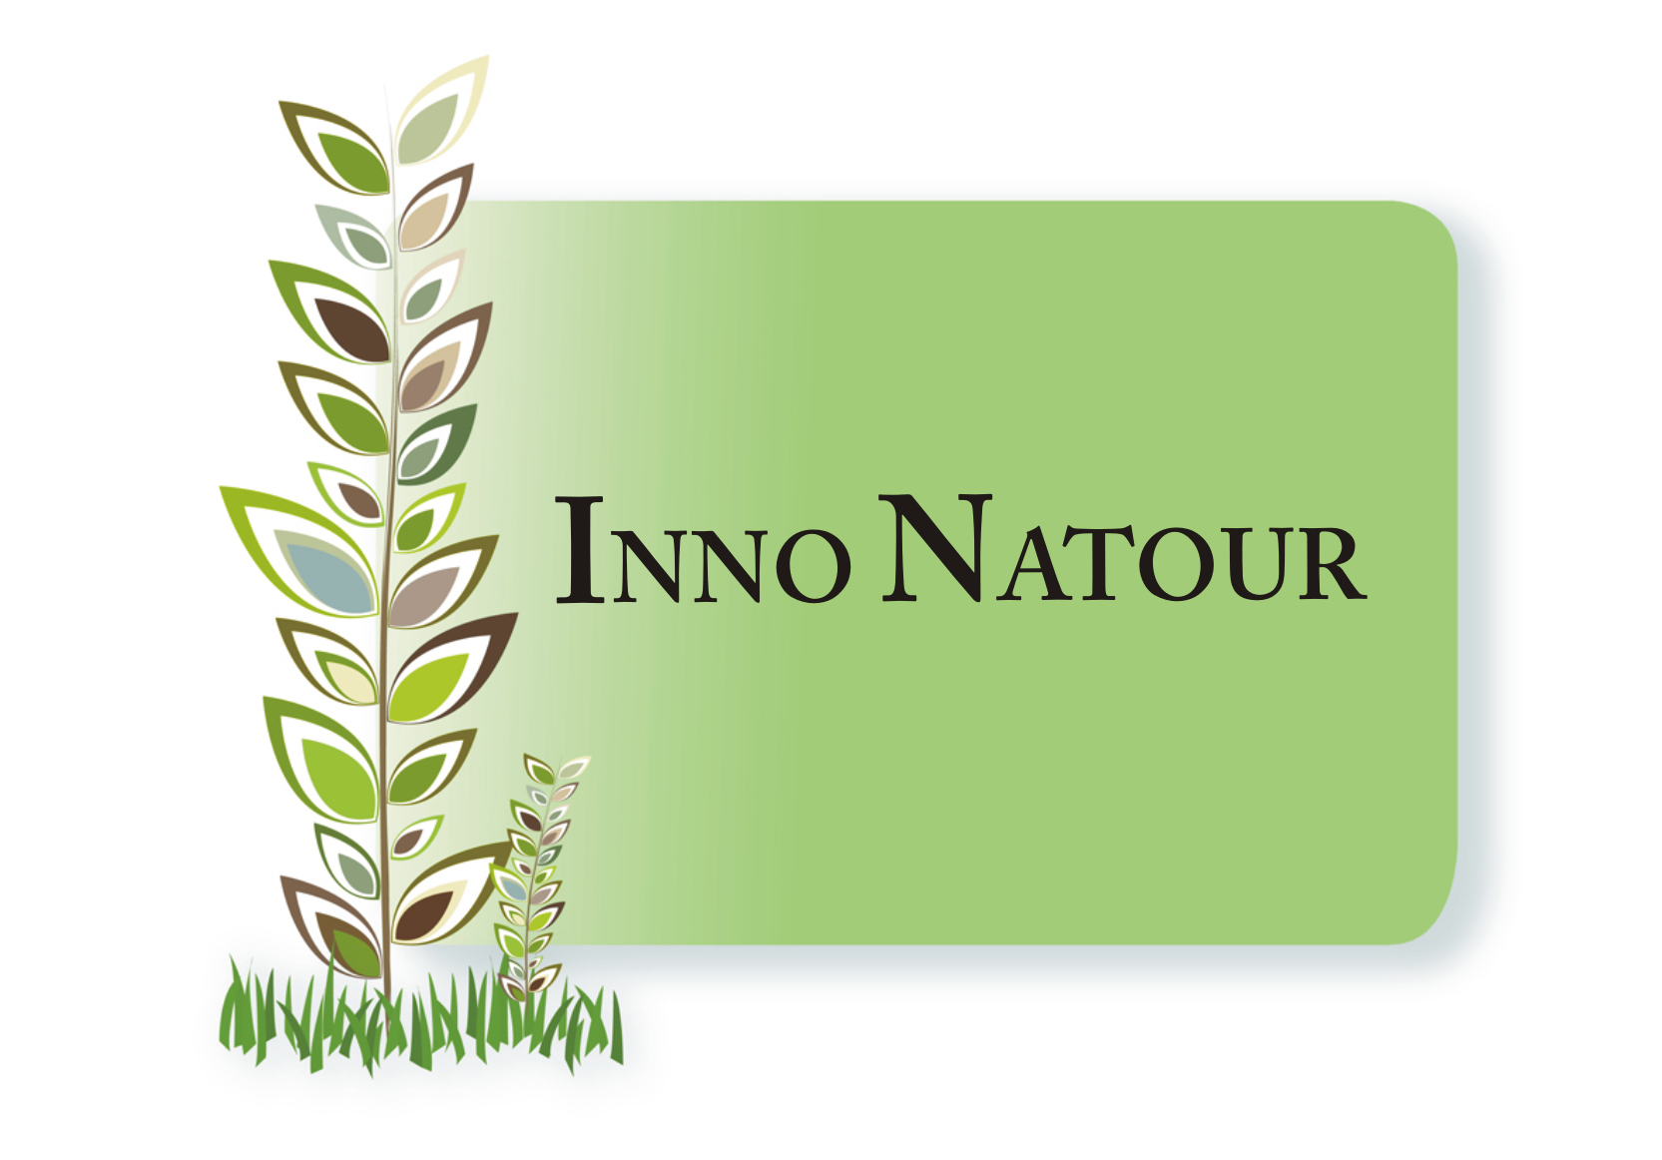

The course is designed for undergraduate and postgraduate students in the field of business, tourism, and environmental sciences and related disciplines.

The course will bring together students from six European countries: Finland, Italy, Austria, Slovakia, Bulgaria and Romania.

The intensive course will be held
at the Stefan cel Mare University of Suceava, from 06 - 19 May 2012

During the intensive course students will learn about the key topics from lectures given by experts with a broad background on innovation research in Europe. Students will work on their case study in workshops with other students and experts, and take part in interesting excursions. The course will be a valuable international experience bringing together students from European countries. Language of the course will be English.

Each student will be granted 10 ECTS after completing the course.
The Programme will cover the costs of your participation in the Intensive Course in Romania: lectures, materials and excursions, and also the travel costs (most economical), the accommodation and subsistence .
If you are interested please fill-in an application form which you can find it at: www.innonatour.usv.ro
Please return the filled-in application with the requested attachments to your local INNO NATOUR Coordinator by 1 February 2012.

We are looking forward to your participation!

Project Coordinator Carmen NASTASE
Email: ncarmen@usv.ro Tel/Fax: +40230 520263

Grand Agreement Reference Number 11-EIP-RO-SUCEAVA01

