

Erasmus Intensive Programme (IP)
2011-12

Final report form for students

How satisfied were you with the duration of the IP:

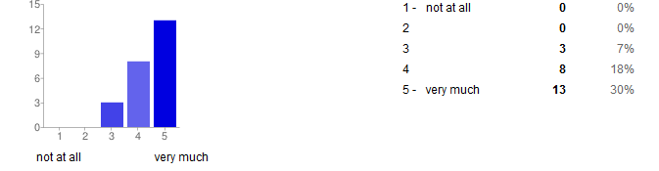

How satisfied were you with the dates of the IP?

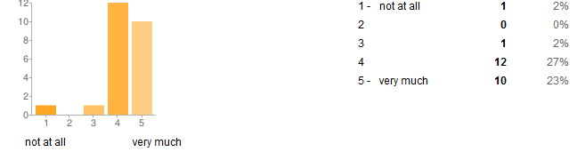
Which were the factors which motivated you to participate?
scale 1-5: 1=not at all, 5=very much

Academic
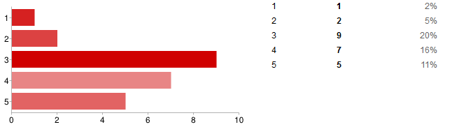

Cultural

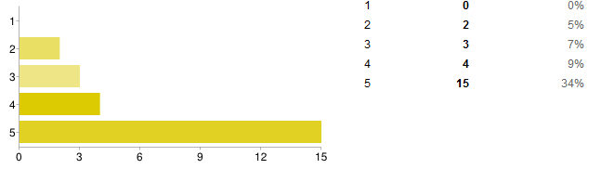

Practice of foreign language
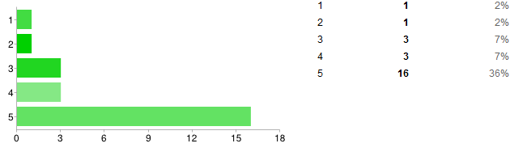
Friends living abroad

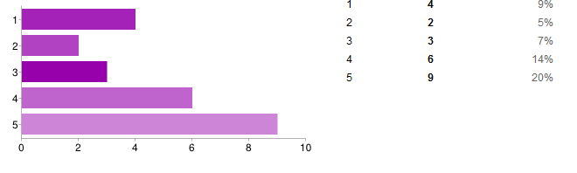
Career plans
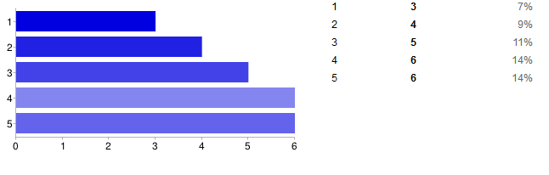

European experience
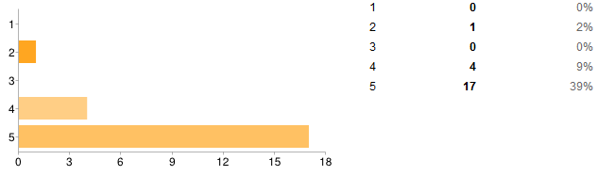

Where did you hear about the IP?

- Home institution
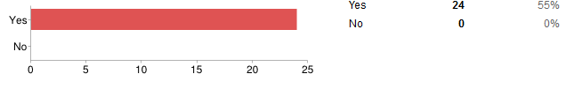
- Host institution
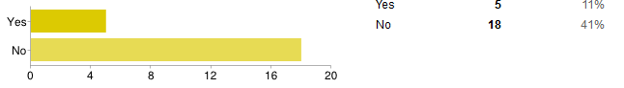

- Other students
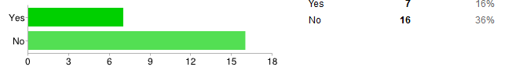

- Former participants
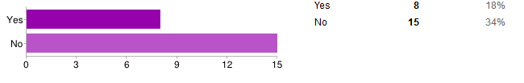
- Internet
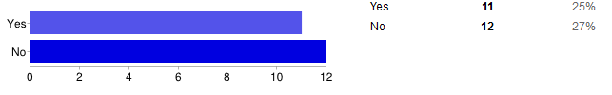

Did you receive adequate support from your home institution and from the host institution before and during the IP?
scale 1-5: 1=poor/negative, 5=excellent

- Home institution
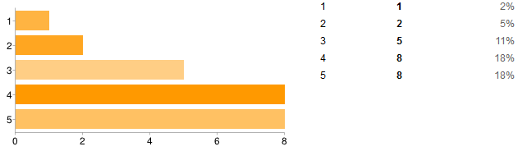

- Host institution
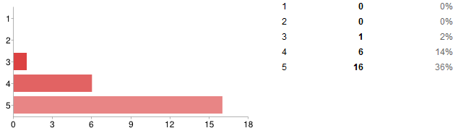
Were you satisfied with your accommodation?
scale 1-5: 1=not at all, 5=very much

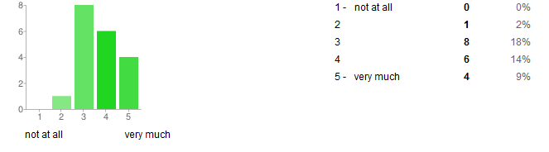
Will you gain recognition for your IP by your home institution?

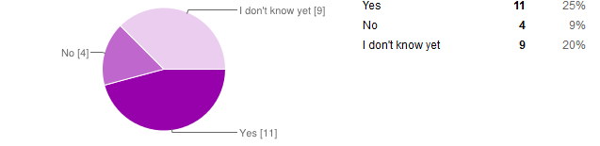

If yes, How will it be recognised?

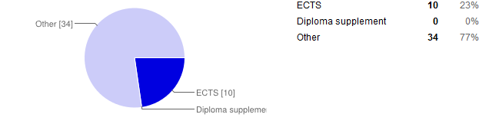

Judgement of academic/learning outcomes of the IP:
scale 1-5: 1=poor/negative, 5=excellent

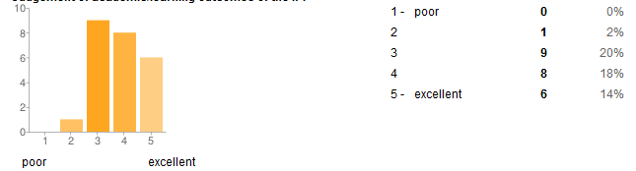
Judgement of personal outcomes of the IP:
scale 1-5: 1=poor/negative, 5=excellent

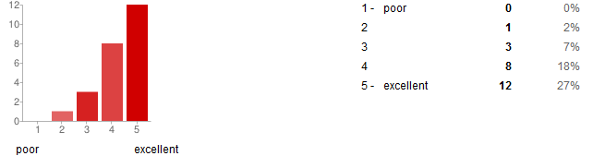

Did you encounter any serious problems during the IP?
scale 1-5: 1=not at all, 5=very much
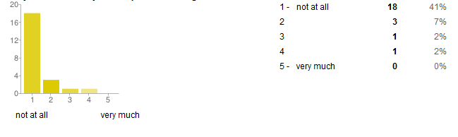

How satisfied were you with the academic activities and the pedagogical aspects of the IP in terms of the following aspects?
scale 1-5: 1=not at all, 5=very much

- The number of hours taught
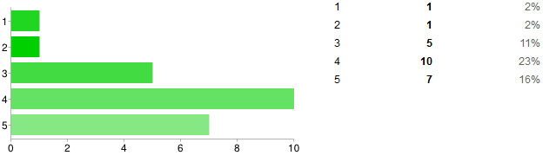
- The equipment used
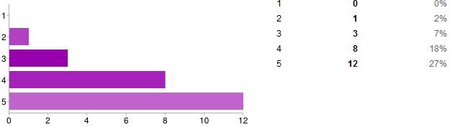- The capabilities and expertise of the professors
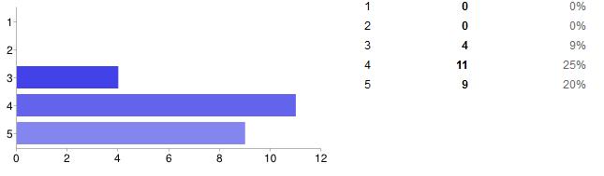
- The overall quality of teaching
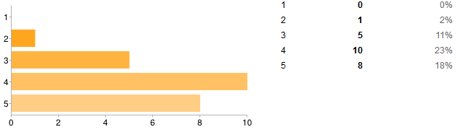

- The expected learning outcomes
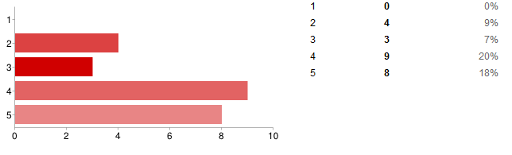
- The activities besides the general course
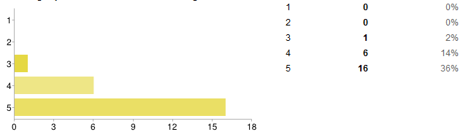
Do you think participation in the IP will help you in your further studies/career?
scale 1-5: 1=not at all, 5=very much

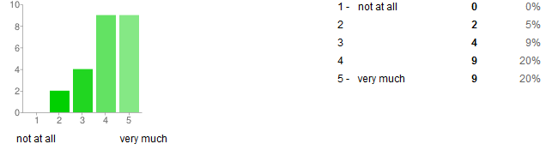
Do you think participation in the IP will help you in finding a job?
scale 1-5: 1=not at all, 5=very much

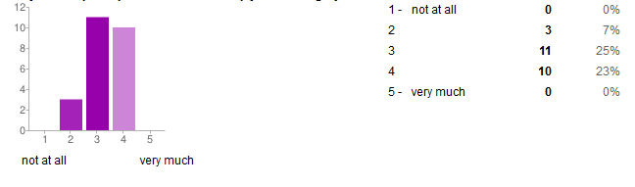

Overall evaluation of the IP:
scale 1-5: 1=poor/negative, 5=excellent

